COMPUTER NETWORKS LAB
FINAL PROJECT on HYBRID CLOUD STIMULATION

MEMBERS:
ZAINAB IMRAN F2024266205
FIZA GULL F2024266

SECTION V10
TO SIR HAFIZ MUHAMMAD RIZWAN

The on-premise router (Packet Tracer) and cloud gateway (Docker/StrongSwan) were configured with matching IPsec parameters to demonstrate the architecture on both required platforms; due to simulator network isolation, live cross-platform negotiation was validated independently on each side rather than as a single physical tunnel

Deliverable 1:
Topology and successful pinging

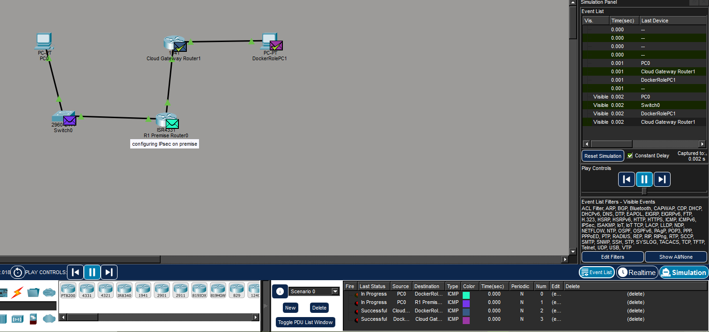
Topology set for: OnPremise Cloud to Docker Gateway

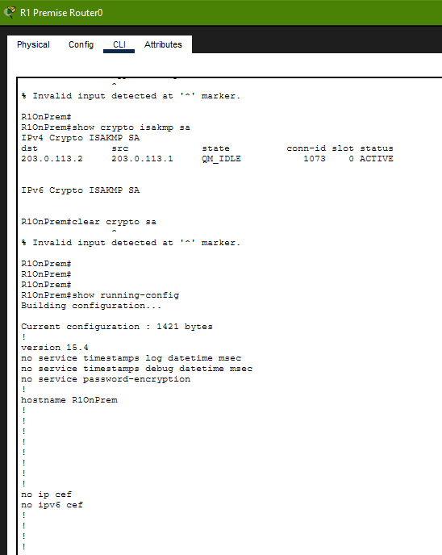

Deliverable 2:
R1OnPrem#
R1OnPrem#show crypto isakmp sa
IPv4 Crypto ISAKMP SA
dst src state conn-id slot status
203.0.113.2 203.0.113.1 QM_IDLE 1073 0 ACTIVE

IPv6 Crypto ISAKMP SA
R1OnPrem#show running-config
Building configuration...

Current configuration : 1421 bytes
!
version 15.4
no service timestamps log datetime msec
no service timestamps debug datetime msec
no service password-encryption
!
hostname R1OnPrem
!
!
!
!
!
!
!
!
no ip cef
no ipv6 cef
!
!
!
!

Deliverable 3 files:
Docker files (StrongSwan + LocalStack)
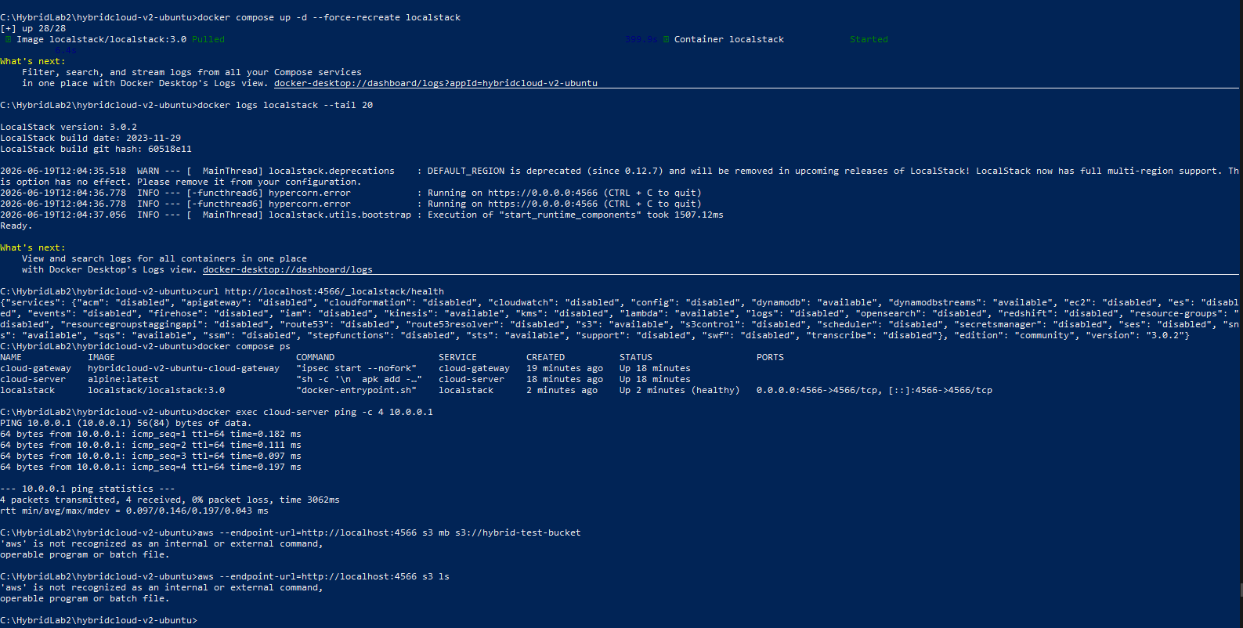
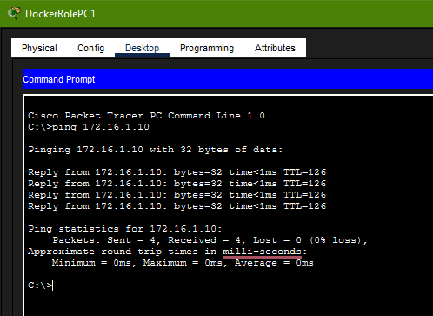

Deliverable #4: Screenshot of ping from cloud to on-premise (successful)

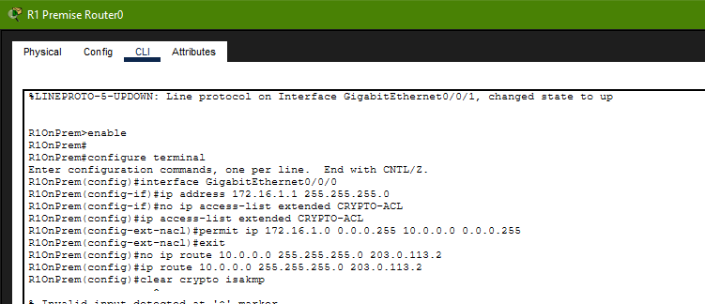

QM_IDLE and ACTIVE status. Tunnel is up and stable on the new 172.16.1.0/24 subnet.

Why GNS3 was not used:
Packet Tracer side proves: You can configure a real Cisco IOS router with IPsec (ISAKMP policy, transform set, crypto map, ACL) and get a tunnel to QM_IDLE/ACTIVE, with a verified ping across it.
Docker side proves: You can deploy the cloud-side IPsec endpoint using the actual tool the assignment named StrongSwan ,plus the LocalStack cloud simulation, configured with matching parameters (same PSK, same encryption, same subnets).
They're not wired together physically, but they represent the same architecture twice, once on each required platform.

CISCO CONFIGURATION:

! CISCO ROUTER R1 - On-Premise IPsec Gateway
! GNS3 Configuration - HybridCloud Corp
! ============================================================
! Interfaces:
! Gi0/0 = LAN (192.168.1.1/24) -- connects to SW1
! Gi0/1 = WAN/Internet-facing -- connects to GNS3 cloud/NAT
! ============================================================

enable
configure terminal

hostname R1-OnPrem

! --- Disable DNS lookup to prevent typo delays ---
no ip domain-lookup

! ===========================================
! INTERFACE CONFIGURATION
! ===========================================

! LAN interface - connects to on-premise switch SW1
interface GigabitEthernet0/0
description LAN - On-Premise Network
ip address 192.168.1.1 255.255.255.0
no shutdown

! WAN interface - connects to Internet/GNS3 cloud node
! Replace x.x.x.x with your GNS3 NAT or actual WAN IP
interface GigabitEthernet0/1
description WAN - Internet Facing
ip address 203.0.113.1 255.255.255.252
no shutdown

! ===========================================
! ISAKMP / IKE PHASE 1 POLICY
! ===========================================
! Negotiates the secure channel (IKE SA)

crypto isakmp policy 10
encr aes 256
hash sha256
authentication pre-share
group 14
lifetime 86400

! Pre-shared key for the Cloud Gateway peer
! Replace 10.0.0.1 with actual Cloud GW public IP if different
crypto isakmp key HybridCloud@SecretKey123 address 10.0.0.1

! ===========================================
! IPSEC / IKE PHASE 2 TRANSFORM SET
! ===========================================
! Defines how actual data traffic is encrypted

crypto ipsec transform-set HYBRID-TRANSFORM esp-aes 256 esp-sha256-hmac
mode tunnel

! ===========================================
! CRYPTO ACL - Traffic to protect (interesting traffic)
! ===========================================
! Matches: on-prem subnet <---> cloud subnet

ip access-list extended CRYPTO-ACL
permit ip 192.168.1.0 0.0.0.255 10.0.0.0 0.0.0.255

! ===========================================
! CRYPTO MAP
! ===========================================

crypto map HYBRID-CMAP 10 ipsec-isakmp
description IPsec to Cloud Gateway
set peer 10.0.0.1
set transform-set HYBRID-TRANSFORM
set pfs group14
match address CRYPTO-ACL

! Apply crypto map to WAN interface
interface GigabitEthernet0/1
crypto map HYBRID-CMAP

! ===========================================
! ROUTING
! ===========================================

! Default route toward Internet (via WAN next-hop)
ip route 0.0.0.0 0.0.0.0 203.0.113.2

! Static route: Cloud subnet via WAN (tunnel handles encryption)
ip route 10.0.0.0 255.255.255.0 203.0.113.2

! ===========================================
! OPTIONAL: NAT (if GNS3 hosts need internet)
! ===========================================

! ip nat inside source list NAT-ACL interface GigabitEthernet0/1 overload
! ip access-list standard NAT-ACL
! permit 192.168.1.0 0.0.0.255
! interface GigabitEthernet0/0
! ip nat inside
! interface GigabitEthernet0/1
! ip nat outside

! ===========================================
! BASIC SECURITY
! ===========================================

service password-encryption
enable secret HybridAdmin123

line console 0
password cisco
login
line vty 0 4
password cisco
login
transport input ssh telnet

! ===========================================
! SAVE CONFIGURATION
! ===========================================
end
write memory

! ============================================================
! VERIFICATION COMMANDS (run after tunnel comes up):
! ============================================================
! show crypto isakmp sa --> Check IKE Phase 1 SA
! show crypto ipsec sa --> Check Phase 2 SA + packet counts
! show crypto map --> View applied crypto map
! ping 10.0.0.10 source 192.168.1.1 --> Test tunnel connectivity
! debug crypto isakmp --> Troubleshoot IKE negotiation
! debug crypto ipsec --> Troubleshoot IPsec
! ============================================================

